**Chapter 4**

**Design**

* 1. **UML Diagrams**

**4.1.1 Use Case Diagram**

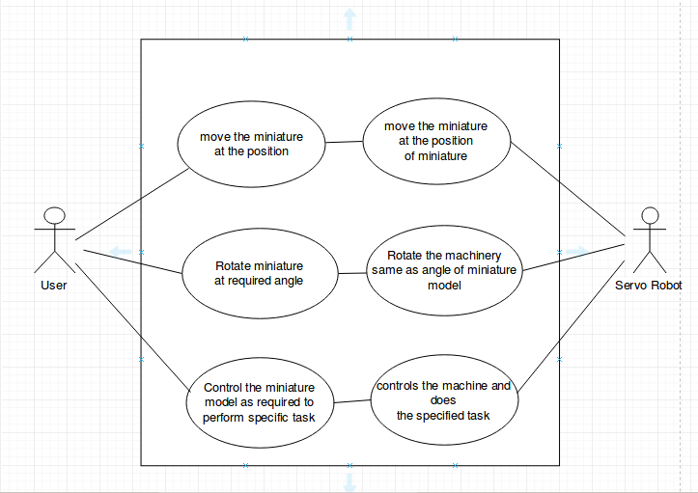

Fig.4.1 Use Case Diagram

**4.1.2 Sequence Diagram**

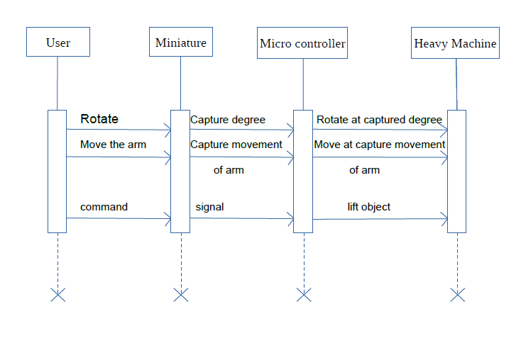

Fig.4.2 Sequence Diagram